Phitron Python

**Lab Final**

Answer all questions, numbers on the right side (blue in colour) indicate marks.

Best wishes.

1. Is there a difference between the type of the expressions "python" and ’python’? **3**
2. What is the difference between the expressions

c = 299792458 and c = 2.99792458 * 10 ** 8? **5**

1. a. Using books, the Web, or any other resource, find out what a **logic gate** is, and, in particular, what a **half adder** is. An output of the work should be a table showing the inputs and outputs for a half adder. **2**

b. Implement a half adder as a few lines of Python code. **10**

c. Write a test program that shows that your implementation works as expected. You should be able to test that your code works for all possible input values. **10**

1. Create a program for storing a week’s worth of rainfall data. Use a list to store each day’s value, entered sequentially by the user. When an entire week has been input, display the days with the minimum and maximum rainfall. **10**
2. Extend your answer to the previous exercise (4) so that it also displays the mean and standard deviation of the values. The mean is the sum of all the values divided by the number of values. The standard deviation is the square root of the sum of the squares of the difference between each value and the mean, divided by the number of items. (You can’t use any library) **10**
3. What does the term referential transparency mean? **2**
4. In Python modules, what is the following code idiom used for? **2**

| if __name__ == '__main__: |
| --- |

1. Convert the following recursive functions into iterative ones: **3+3+3**

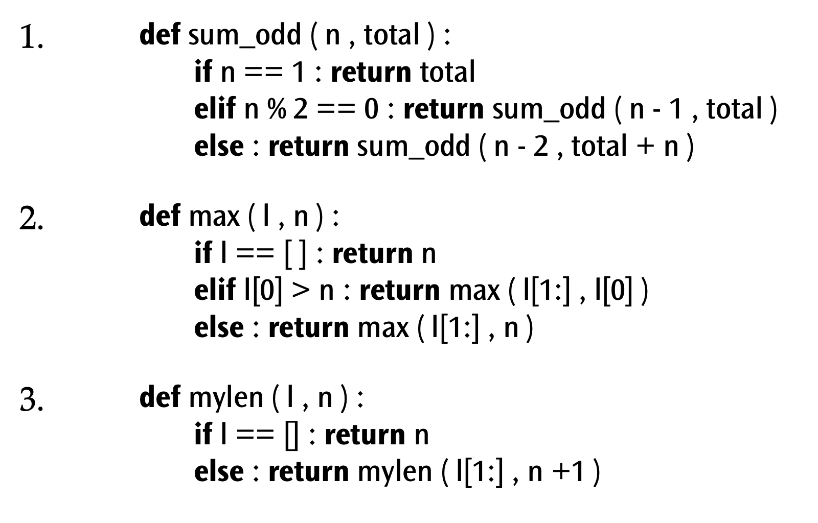

1. Look at the following program:

| file = open ( 'words.dat' , 'w' )  word = ''  while word != 'END' :   word = raw_input ( 'Enter a word (enter END to quit): ')   file.write ( word + '\n' )  file.close ( ) |
| --- |

This is a very simple program for storing a list of words in a file. When executed it expects the user to enter some words, one per line, finishing with the word “END”.

1. What is the name of the file containing the words? **2**
2. How many words are stored in the file? **2**
3. Write a program to read the data file and display a numbered list of the contents, such as:

1: chicken

2: apple

3: fox

4: aubergine

5: END **3**

1. Note that “END” is always the last word displayed. This isn’t really the behaviour we want, since “END” is meant as a command, not a word. Change the program so that it no longer stores “END” in the file. **5**
2. There’s still a problem: we can’t put the word “END” into the file even if we wanted to. Maybe we should use the empty string (’’) to signal the user’s desire to quit? Modify the program to use the empty string to terminate user input.  **10**

10. Observer is a behavioural design pattern that allows some objects to notify other objects about changes in their state. The Observer pattern provides a way to subscribe and unsubscribe to and from these events for any object that implements a subscriber interface.

Write a Python Program to demonstrate Observer Design Pattern, explain your code in writing. **15**